Calculate Trip Cost

Project

Software Requirements Specification

|  |  |  |  |
| --- | --- | --- | --- |
|  | Prepared By | Reviewed By | Approved By |
| Name | Four_0_Four_Finders | Devathilagai |  |
| Role | Programmer Trainees | Batch Trainer |  |

1. **Introduction**

TripAdvisor is the World’s largest travel platform. The website offers online hotel reservations and bookings for transportation, lodging, travel experiences, and restaurants.

* 1. **Intended Audience**

Business Unit (BU) SME

Academy coach

Technical Trainer

* 1. **Project Scope**

This document defines at a functional level the business activities that are encompassed by the system and the rules that apply to them. It also encompasses some of the key high and low level technical requirements of the system.

It draws heavily on both proposed Framework and Business Rules and the Technical Architecture documents. The scope of the detailed analysis project phase specifies that this document will include.

- Classification of requirements according to their functional areas.

- A description of each process in the system, including their inputs, outputs, and data transformation rules.

1. **Overall Description**
   1. **Operating Environment**

Windows operating system

Web application

1. **Requirements**

This part of the requirement document elaborates the “Booking of Holiday Homes”, “Cruise line” part of the application and also listing out required details from them

**3.1 Functional Requirements**

**3.1.1 Requirement 1**

* The user clicks the Holiday homes button.
* The user enters “Nairobi” in "Where to" text field and selects .
* The user enters 15/12/21 as date under "Check in" date field.
* The user enters 20/12/21 as date under "Check out" date field.
* The user enters 4+ guests under "Guests" listbox field.
* The user selects “Traveller rating” under "Sort by" listbox field.
* The user selects the "Elevator/Lift access" checkbox field under "Amenities".

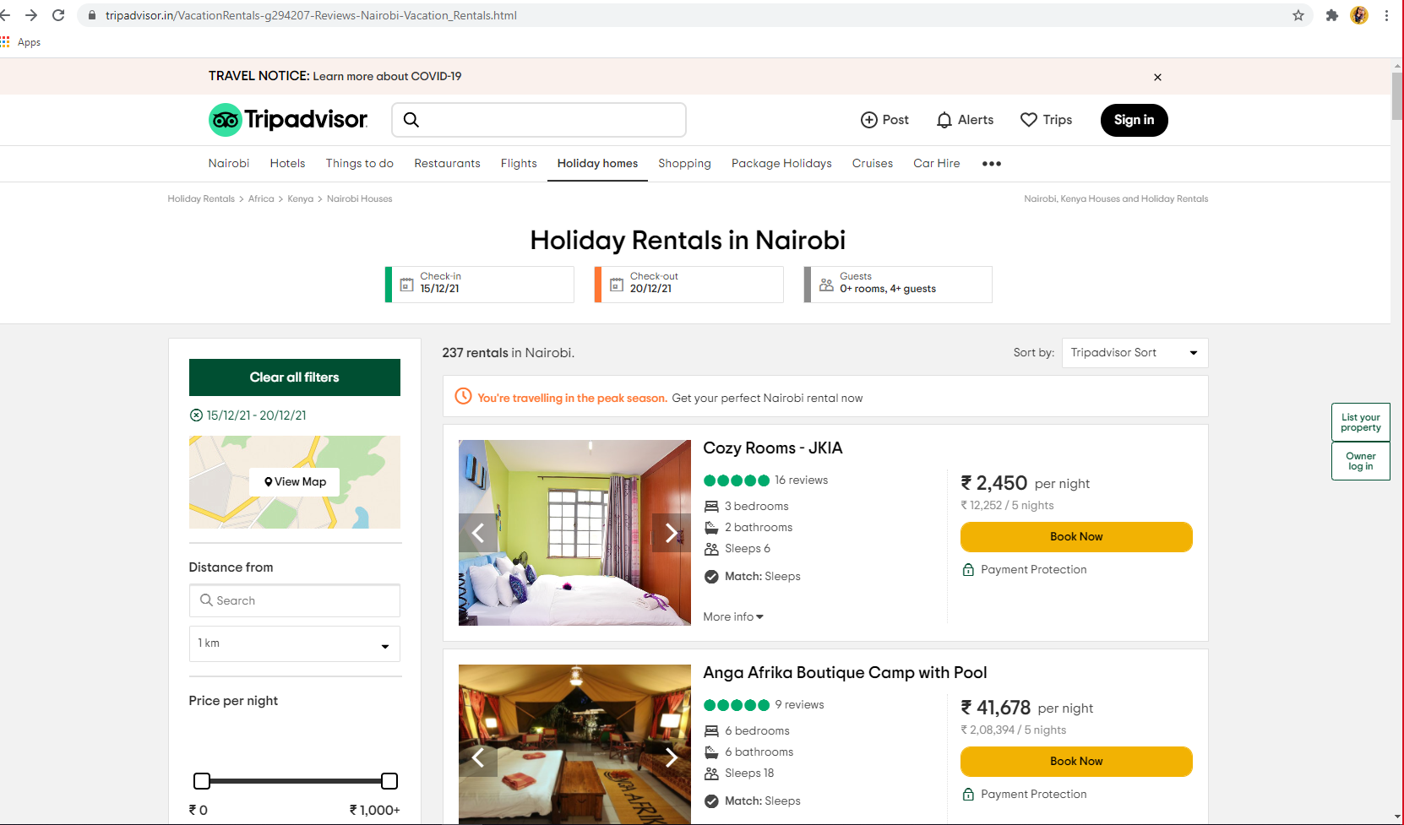

**3.1.2 Requirement 2**

* The user navigates to TripAdvisor/Cruises.
* The user selects a valid value from "Cruise Line" List box field.
* The user selects a valid value from "Cruise Ship" Listbox field.
* The user clicks on the [Search] button.

